**Exp No: 4**

**Date:**

**DESIGN A DESK CALCULATOR USING LEX TOOL**

**AIM:**

To create a calculator that performs addition, subtraction, multiplication and division using lex tool.

**ALGORITHM:**

1. Initialize variables and declare a function prototype.
2. Define patterns for digits, arithmetic operations, and line breaks.
3. Implement lexical rules to perform actions based on matched patterns.
4. Define a function to convert tokens to floats and perform arithmetic operations.
5. Invoke lexical analysis in the main function.
6. Indicate the end of input with the yywrap() function.

**PROGRAM**:

%{

int op = 0,i;

float a, b;

int digi();

%}

dig [0-9]+|([0-9]*)"."([0-9]+)

add "+"

sub "-"

mul "*"

div "/"

pow "^"

ln \n

%%

{dig} {digi();}

{add} {op=1;}

{sub} {op=2;}

{mul} {op=3;}

{div} {op=4;}

{pow} {op=5;}

{ln} {printf("\n The Answer :%f\n\n",a);}

%%

int digi() {

if(op==0)

/* atof() is used to convert

- the ASCII input to float */

a=atof(yytext);

else{

b=atof(yytext);

switch(op) {

case 1:a=a+b;

break;

case 2:a=a-b;

break;

case 3:a=a*b;

break;

case 4:a=a/b;

break;

case 5:for(i=a;b>1;b--)

a=a*i;

break; }

op=0; } }

int main(int argv,char *argc[]) {

yylex();

}

int yywrap() {

return 1;

}

**OUTPUT**:

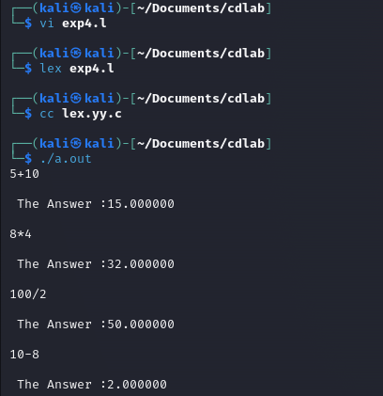

**RESULT**:

Thus, a calculator that performs addition, subtraction, multiplication and division using lex tool is implemented.